The International Conference on Sustainable Halal Industry
(The title of the article should be clear (not ambiguous) and identifying the content. The format of the title uses Times New Roman 14 Bold, Centerd Allignment, and must be Capital Each Word. It is one space with 0pt spacing (before) and 12 pt spacing (after).

First Author ¹*, Second Author ², and Last Author ³
(Without honorary name or degree and should be written in full name)

¹ First Affiliation, ² Second Affiliation, ³ First Affiliation
The affiliation is written in full name (not abbreviation) and complete address just as the example below:
Departement Islamic Economics, Faculty of Islamic Business and Economics, UIN Walisongo Semarang, Indonesia
Jalan Prof. Dr. Hamka Kampus III UIN Walisongo Semarang 50185
*Corresponding email: ferrykhusnulmubarok@walisongo.ac.id

Article information | ABSTRAK
Article history:  Received : ....................  Accepted : .....................  Published : ..................... | Abstrak dideskripsikan secara singkat, jelas, dan padat, meliputi pokok-pokok seperti tujuan penelitian, metode, serta ringkasan hasil penelitian. Abstrak ditulis dalam satu paragraf dalam bahasa Inggris dengan panjang maksimum 200 kata.  Keywords: keyword 1, keyword 2, keyword 3 (3 to 5 keywords)
 | ABSTRACT
The abstract is described briefly, clearly, and concisely, covering key points such as the research objectives, methods, as well as a summary of the research results. The abstract is written in a single paragraph in an English maximum of 200 words by length.

Keywords: keyword 1, keyword 2, keyword 3 (3 to 5 keywords)

©2021 FEBI UIN Walisongo Semarang. All rights reserved

Introduction

Papers should be submitted in English or Indonesia as doc Ms Word. Each paper should be single-spaced with wide margins, on one side only of the paper, preferably of A4 size, with pages in numbered sequence. The font used for the main body should be 12 pt Times New Roman and for the bodynotes 12 pt Times New Roman or the closest font available. Footnotes should be numbered consecutively and placed within the text. Please leave one line empty before and after every section. In introduction clearly explain the nature of the problem, previous work, purpose, and contribution of the paper. Ensure that your paper has been fully proofread before submitting it for publishing. In Introduction, Authors should state the objectives of the work at the end of introduction section. Before the objective, Authors should provide an adequate background, and very short literature survey in order to record the existing solutions/method, to show which is the best of previous researches, to show the main limitation of the previous researches, to show what do you hope to achieve (to solve the limitation), and to show the scientific merit or novelties of the paper. Avoid a detailed literature survey or a summary of the results. Do not describe literature survey as author by author, but should be presented as group per method or topic reviewed which refers to some literatures.
Example of novelty statement or the gap analysis statement in the end of Introduction section (after state of the art of previous research survey): “........ (short summary of background)....... A few researchers focused on ....... There have been limited studies concerned on ........ Therefore, this research intends to ................. The objectives of this research are .........”.

Literature Review

This section contains relevant literature related to the research and development of the proposed hypothesis (if any). This section also briefly discusses the theory used to describe the relationship between concepts (presented in the subtitles) and the relationship between these concepts is presented in the form of a conceptual framework drawing.

Method

It contains reserarch design, population, sample, techniques of data collection and analysis, in Times New Roman 12. It does not need to present any research method for conceptual article/ literature study, it is only result and discussion ritght after introduction.

Result and Discussion

The result of the article contains the data analysis written descriptively using Times New Roman 12. Tables and figures in each article is three (3) at most, B&W, not colorful.
Discussion presents each of the findings compared to relevant theories or previous studies, actual facts, comments, and reasonable analysis from researchers.
The utilization of sub-chapter in discussion corresponds to the needs of discussion. For instance:
Sub Chapter 1 (Times New Roman 12, bold)
Sub Sub Chapter 1
Sub Sub Chapter 2
Sub Chapter 2 (Times New Roman 12, bold)
Sub Sub Chapter 1
Sub Sub Chapter 2
Sub Chapter 3 (Times New Roman 12, bold)
Sub Sub Chapter 1
Sub Sub Chapter 2
Figure
Figures should be numbered consecutively (e.g., Figure 1, etc.). The caption should be center justified and placed under the figure.
Figure 1.
Kurva Supply and Demand
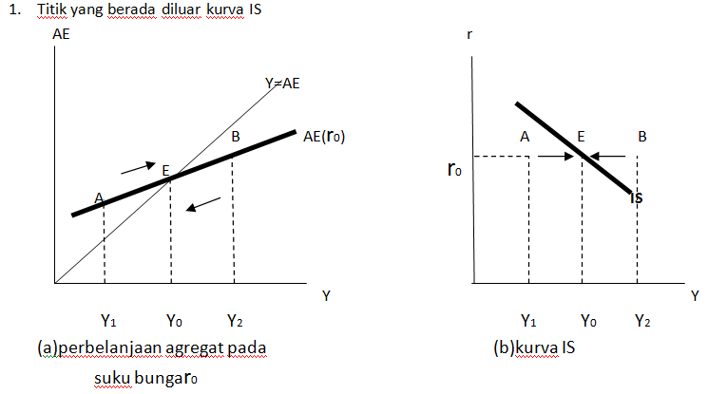

Tables
Tables should be arranged consecutively (e.g., Table 1, etc.). The caption should be (center justified) and placed above, as like the following example.
Table 1.
The Growth of Islamic Banks and Conventional Banks Number Year 2013 – 2017
Group of Banks |  | 2013 |  | 2014 |  | 2017
Islamic Banks | 11 |  | 12 |  | 13
Conventional Banks | 120 |  | 119 |  | 115
Islamic Business Units | 23 |  | 22 |  | 21
Islamic Rural Banks | 163 |  | 163 |  | 167
Source: Indonesia Banking Statistics 2013-2017, processed
Mathematical Formula
Mathematical formulas should be numbered and clearly presented using microssoft
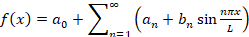 (1)
Conclusion

It contains conclusion and suggestion. Conclusion briefly illustrates the results that address the hypotheses and/or research purposes or findings. It is the summary of the research and discussion, relevant to the findings, presented descriptively, not numeric.
Suggestion provides things expected to conduct related to further ideas the research has proposed.

Acknowledgment

Recognize those who helped in the research, especially funding supporter of your research. Include individuals who have assisted you in your study: Advisors, Financial supporters, or may other supporter i.e. Proofreaders, Typists, and Suppliers who may have given materials.

References

Citations and references must strictly follow APA (American Psychological Association) style. References should relate only to the content that is cited within the text of the manuscript. Consulting the APA style manual (http://www.apastyle.org/pubmanual.html) is highly recommended for compiling manuscript submissions.

References should appear as
Book with one author:
Author, A. A. (2017). Title of work. Location/City, State: Publisher.

Book with two authors:
Author, A. A., & Author, B. B. (2017). Title of work. Location/City, State: Publisher.

Book with more than two authors:
Author, A. A., Author, B. B., & Author, C. C. (2017). Title of work. Location/City, State: Publisher.

Journal article:
Ruchba, S. M., & Suhada, F. (2015). The impact of regional autonomy and monetary crisis on economic growth in Yogyakarta. Economic Journal of Emerging Markets, 7 (3), 60-68.

A publication in press:
Kuncoro, H. (in press). Does the sustainable fiscal policy foster its credibility? Economic Journal of Emerging Markets.

Edited book:
Gregoriou, G. N. (Ed.). (2009). Emerging Markets: Performance, Analysis and Innovation. Florida, USA: CRC Press.

Chapter in an edited book:
Courant, P. N., Gramlich, E. M., & Rubinfeld, D. L. (1979). The stimulative effects of intergovernmental grants: or why money sticks where it hits. In P. Mieszkowski, & W. H. Oakland (Ed.), Fiscal Federalism and Grants-in-Aid (pp. 5-21). Washington, DC: The Urban Institute.

Website:
Prasetyo, P. E., Sudarma, K., & Sulaha, A.S. (2014). Economic policy impact on competitiveness and efficiency of textile industry in central java. Economic Journal of Emerging Markets, 6 (2), 85-95. Retrieved August 23, 2016, from http://journal.uii.ac.id/index.php/JEP/issue/view/417

Unpublished doctoral dissertation or master’s thesis: Mosquera, C. M. R. (2009). Essays on Economic Growth, Financial Integration and Exchange Rates. Unpublished doctoral dissertation, University of Pittsburgh, Pennsylvania.

Published proceedings:
Altinbas, H., & Biskin, O.T. (2015). Selecting macroeconomic influencers on stock markets by using feature selection algorithms. In E. Hromada (Ed.), IISES 3rd and 4th Economics and Finance Conference: Vol. 30. Procedia Economics and Finance (pp. 22-29). London: International Institute of Social and Economic Sciences.

A presented paper:
Lagos, Ricardo. (2009, October). Asset Prices, Liquidity, and Monetary Policy in an Exchange Economy. Paper presented at the Annual Economic Policy Conference of the FRB of St. Louis: "Debt, Financial Markets and Monetary Policy", Federal Reserve Bank of St. Louis, US.

